

GUI Design

Choices

DTM

Document Trace Manager



Made by: Serena Kenter

Date: 18-01-2024

At the start of this project, I took the initiative to craft a design, aiming to provide insights into the rationale behind each decision and offering a view of the project's intended look and operation. This document serves as a detailed of the design choices I made.

This is the login screen. I wanted to make it exceptional and a bit different, but still readable and clear. By adding a green color (because of the 4-rest logo) it has more personality.

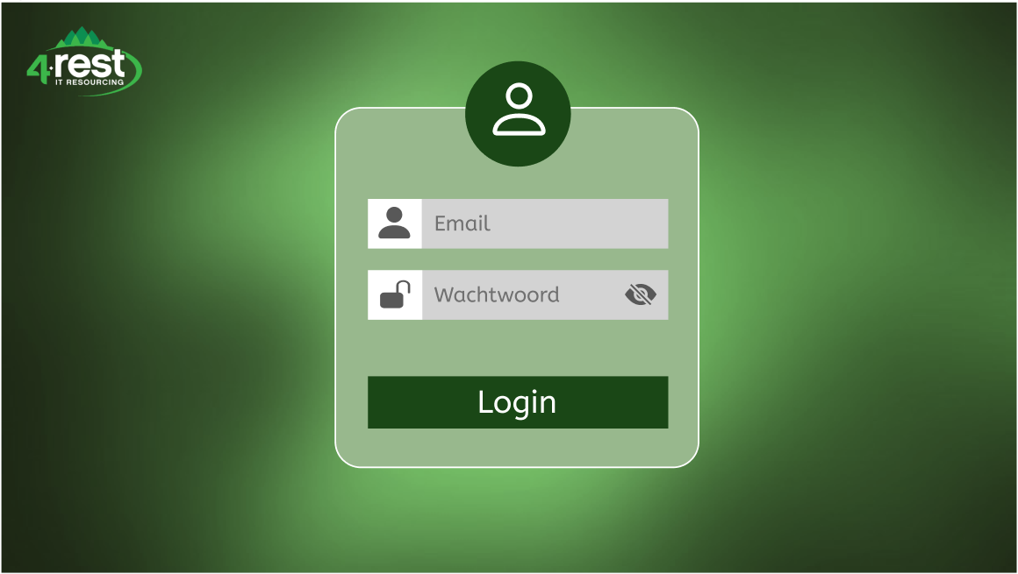

This is the document overview. This is the website's main page, which makes it the most important. That’s why I have chosen a minimalistic design, so it looks very clear.

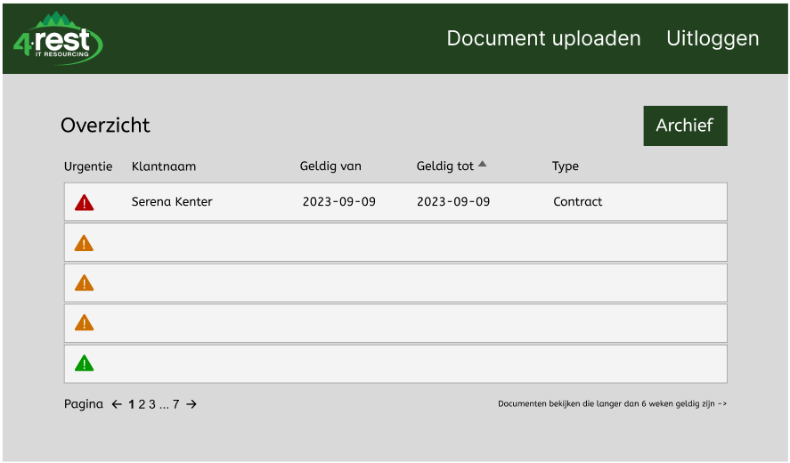

This is the upload page where documents can be uploaded to the database. There is a drag & drop for efficiently and also a button to search your files. In the upper right corner, there is a search field to search for existing employees.

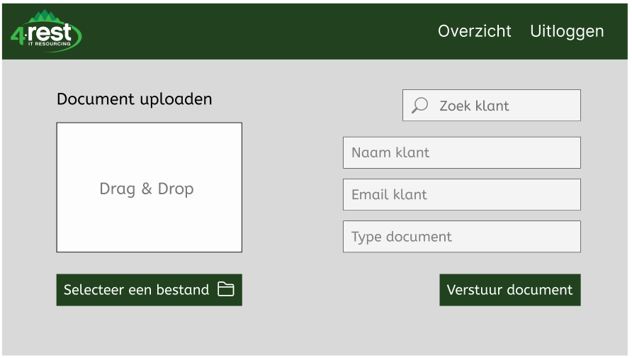

These 2 pages are made for the profile. Left is a sidebar to navigate to different pages within your profile.

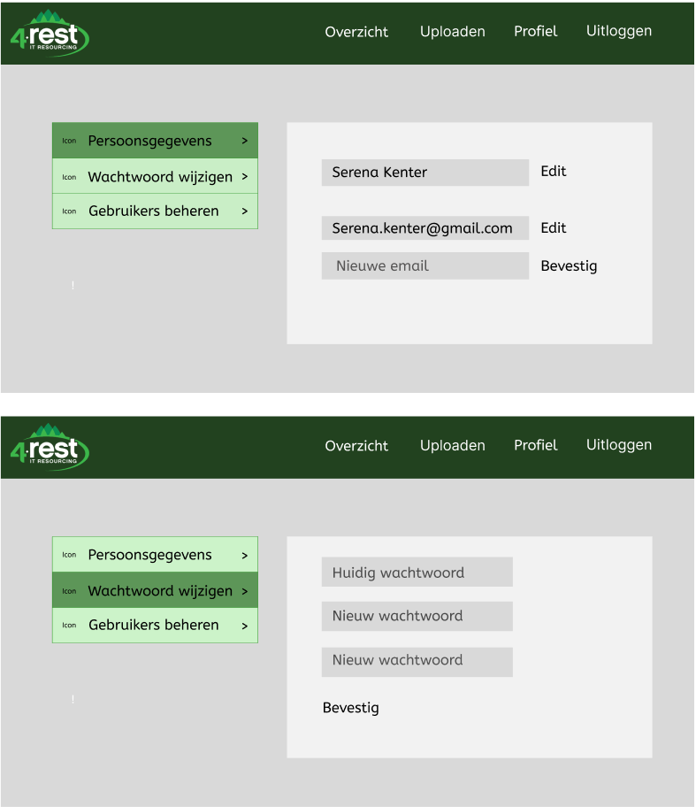

These pages are also made for the profile. Here you can manage the users which can access this application. You can add and deleted users with this solution.

